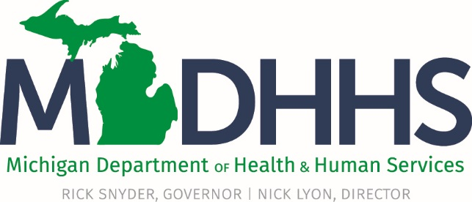

# **Frequently Asked Questions – Flint Medicaid Healthcare Coverage**

Many residents in the Flint community have become eligible for additional healthcare coverage through Medicaid under a waiver recently approved by the U.S. Department of Health and Human Services. Michigan applied for this waiver to ensure that Flint residents get the health services they need as a result of the Flint water emergency. Enrollment for this coverage could begin Monday, May 9, 2016.

## Who is eligible for this coverage?

Anyone under the age of 21 or any pregnant woman who was served by water from the Flint water system and lived, worked or received childcare or educational services at an address served by the Flint water system since April 2014 – and whose family incomes are 400 percent or less of the federal poverty level. Children born to a woman served by the Flint water system during this period also are part of this eligible group. Four-hundred percent of the federal poverty level is $47,520 for one person, or $97,200 for a family of four.

Others in this group with incomes greater than 400 percent of the federal poverty can apply for Medicaid health coverage through a “buy-in” option to become available later this year.

## What if I already am covered by Medicaid?

If you have prior coverage, you may have already received a letter in the mail from MDHHS that explains you will receive these additional services. If you have questions, you may call the Beneficiary Help Line at 1-800-642-3195 (TTY 1-866-501-5656 for persons with hearing and speech disabilities).

## What if I’m not already covered through these services?

If you meet the eligibility criteria and your income is 400 percent or less of the federal poverty level, you should apply for services. The fastest way to apply is online at [www.michigan.gov/mibridges](http://www.michigan.gov/mibridges). You also can apply by calling 1-855-789-5610 (TTY 866-501-5656 for persons with hearing and speech disabilities).

## When did I become eligible for expanded services?

The waiver for this program was approved by the U.S. Department of Health and Human Services on March 3, 2016. Enrollment into coverage could begin May 9, 2016, but coverage is retroactive three months prior to enrollment into Medicaid and no earlier than March 1, 2016.

## What are targeted case management services?

These services, which are part of the additional coverage, are designed to ensure that you receive the full spectrum of health and other services that you and your children need. A case manager will meet with you to help you create a plan of care that includes needed medical, social, educational and other services and will assist you with necessary referrals. If you are receiving the additional coverage, you can receive targeted case management services by contacting your doctor, your Medicaid Health Plan, or calling Genesee Health System at 810-257-3777.

## Are there additional costs for me?

Those who qualify for this coverage will not have to pay premiums, contributions or co-pays for their State of Michigan health care coverage

## Where can I find out more about Flint-related water issues?

For more information, visit [Michigan Flint Water Webpage](http://www.michigan.gov/flintwater) http://www.michigan.gov/flintwater.